Create angular application: ng new httpdemo

Move to the app folder: cd httpdemo

Run the application: ng serve

Open app in VS Code

In src folder create new folder named server

Open terminal and move to that folder using cd command

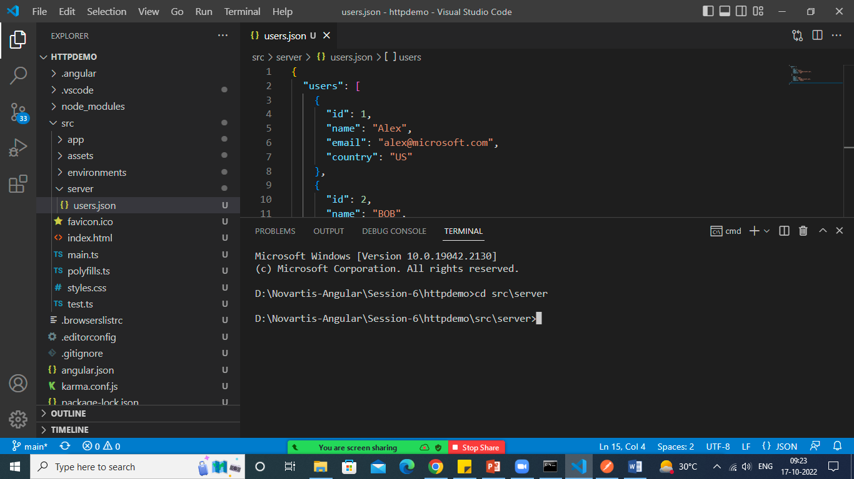

Now execute below command to install json-server

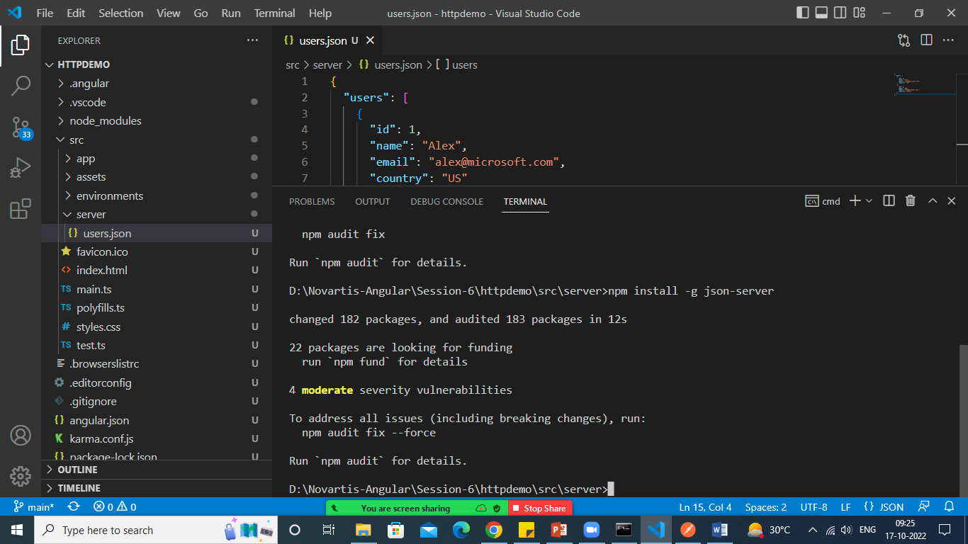

Right click on server and create users.json file

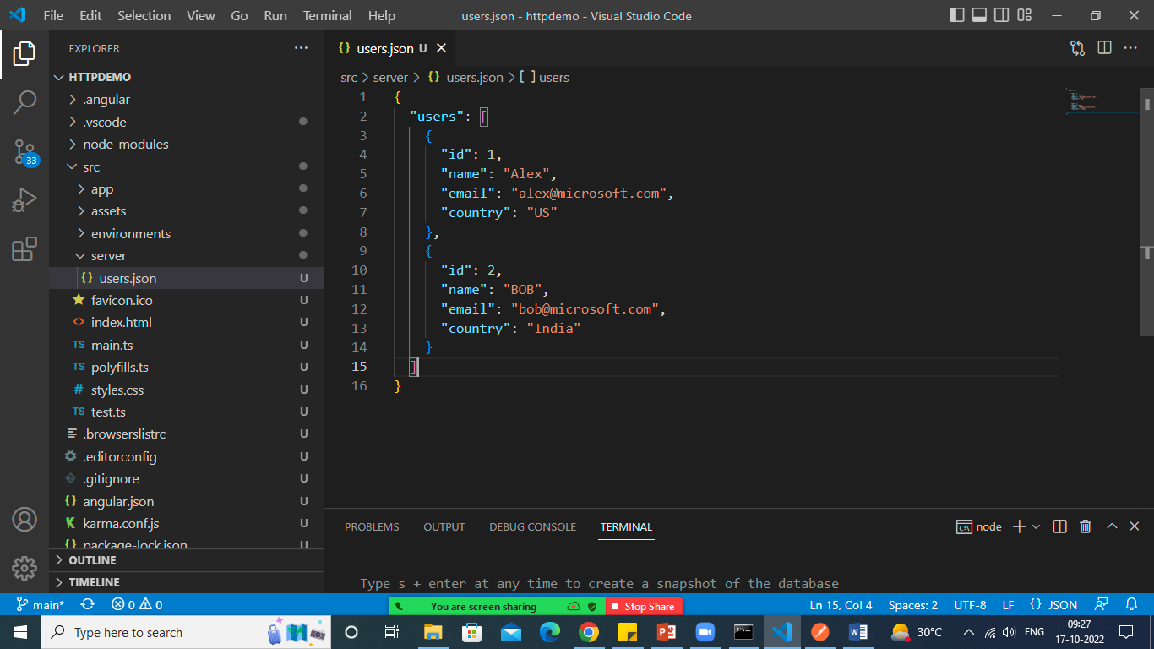

Execute below mentioned command to open a file as an api

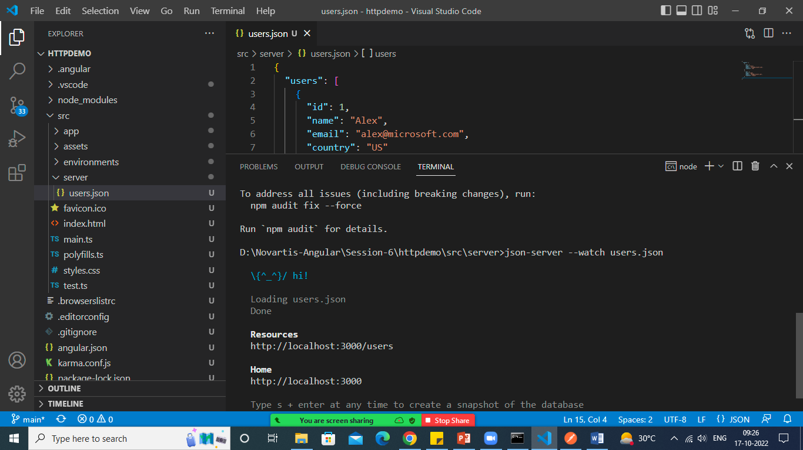

You can test the url <http://localhost:3000/users> for CRUD operation

Open PostMan

Get Request

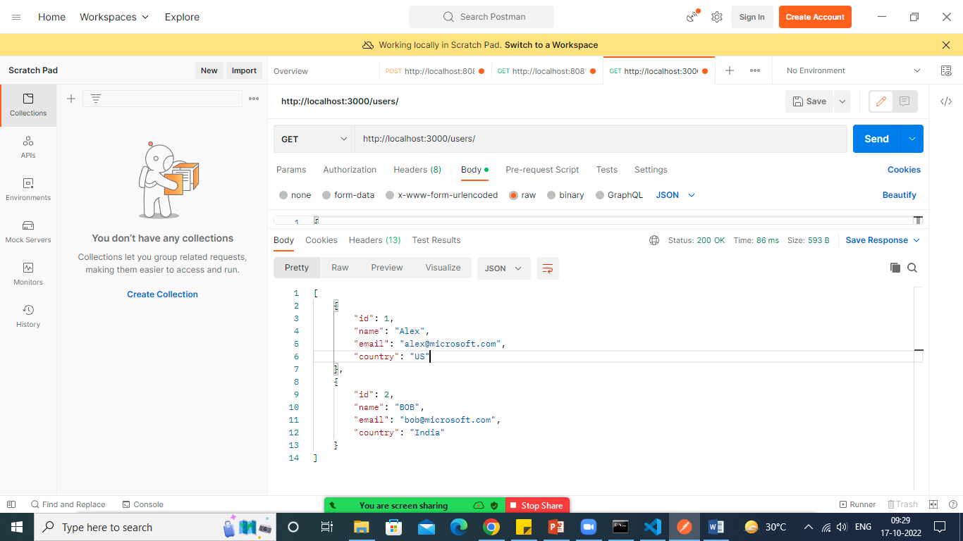

getById

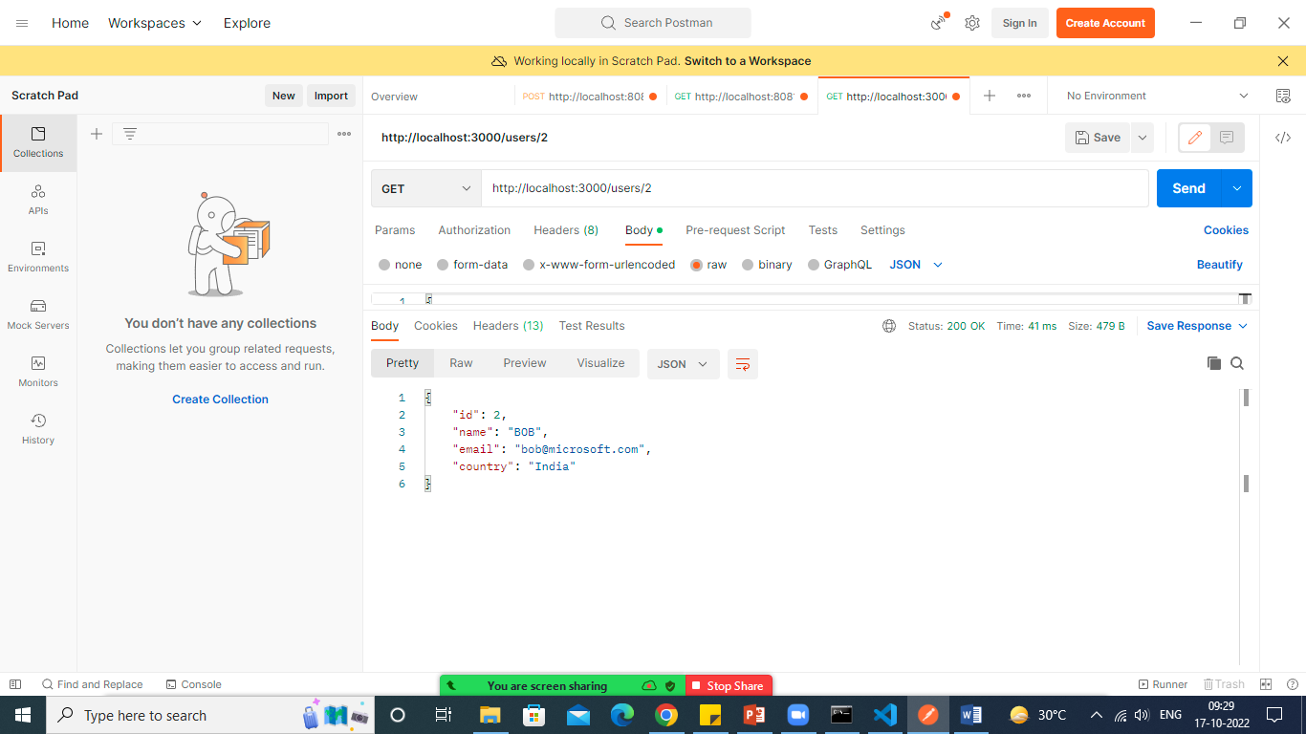

Create New Data: POST request

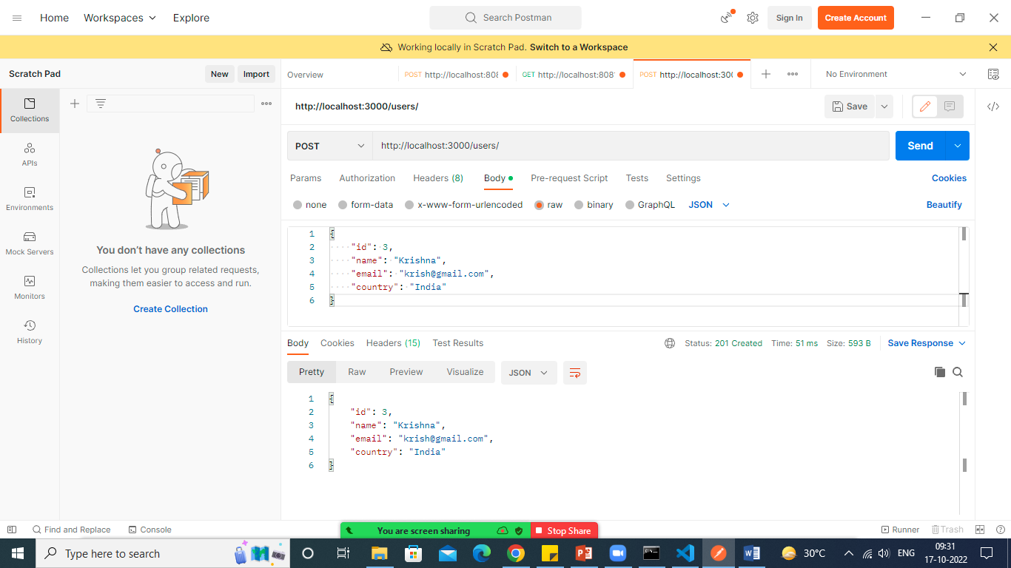

Put Request to update the data

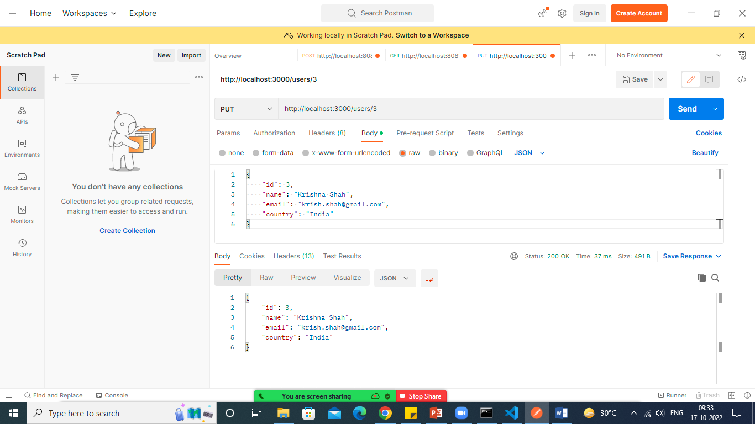

Patch method to update only single value

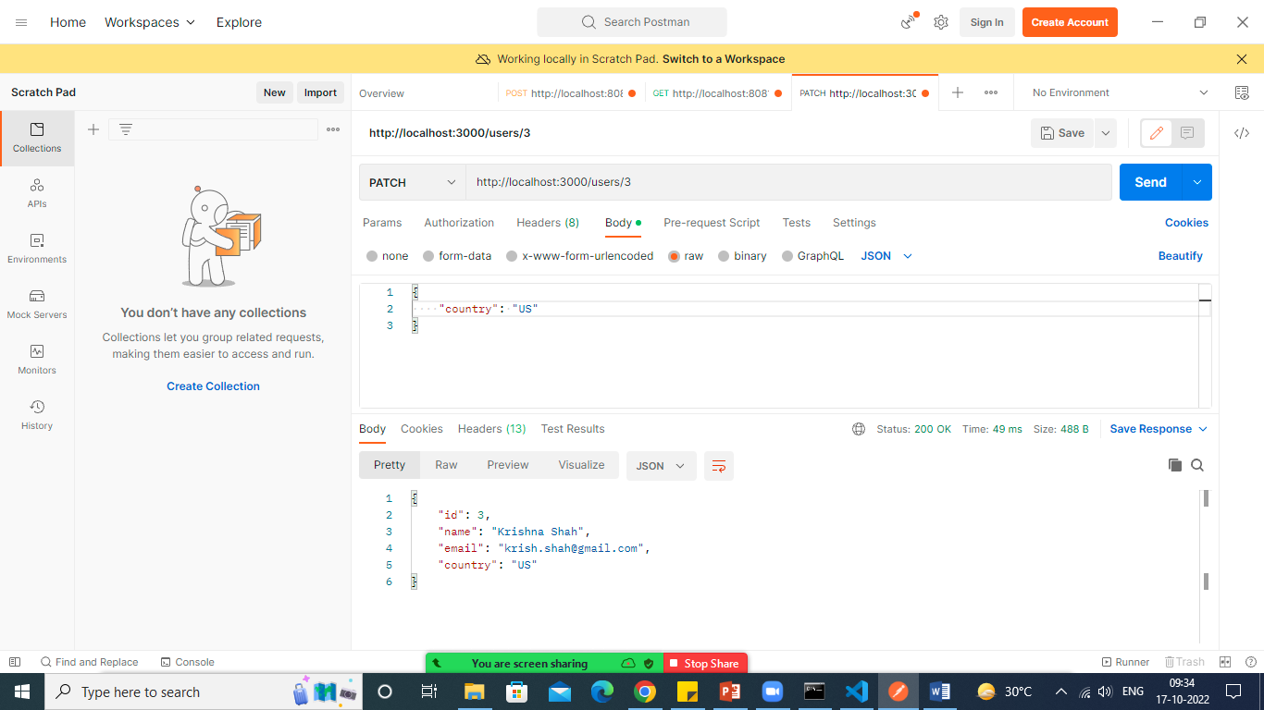

Delete request

